York FA Cup ties to be played 23/24 November 2024, with many thanks to our sponsors
Construction Marine Ltd
Your Move (Anscomb)
Fulcrum Finacial
Oakwood Landscaping

Senior Cup
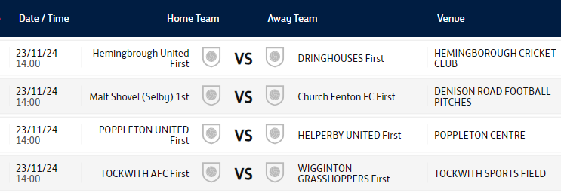
Saturday Junior Cup
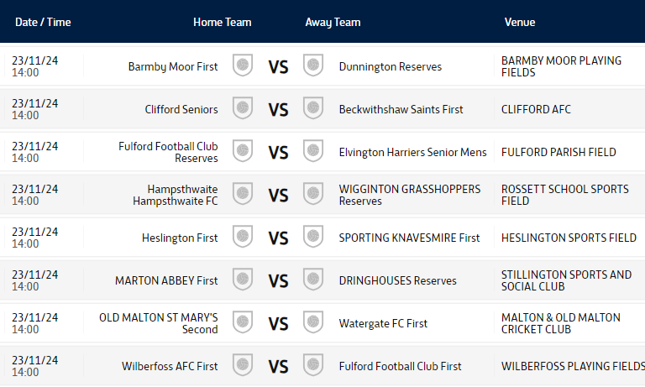

U19s
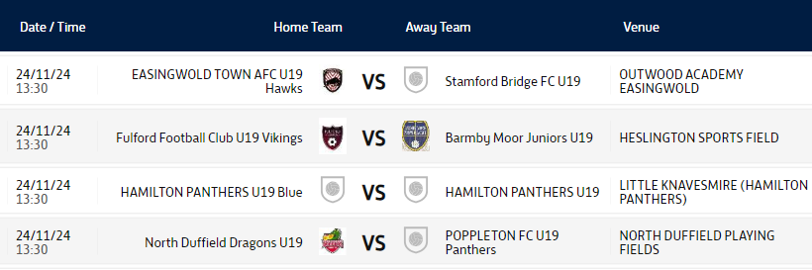
U16s
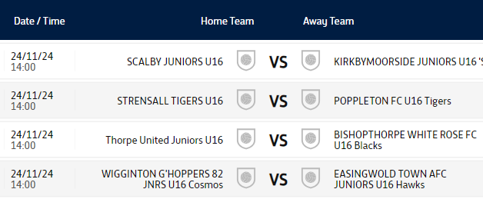

U15s
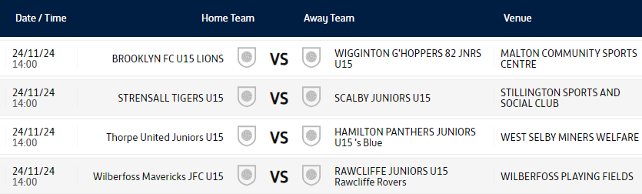

U14s
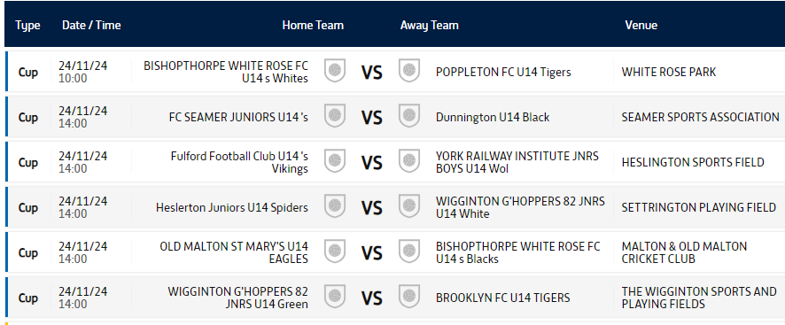

U13s
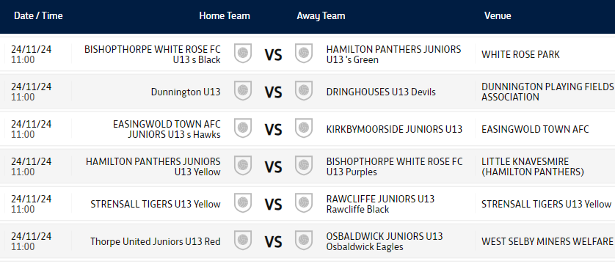

U12s
